- Describe your project (what is it? What fabric/pattern did you use? Why?)

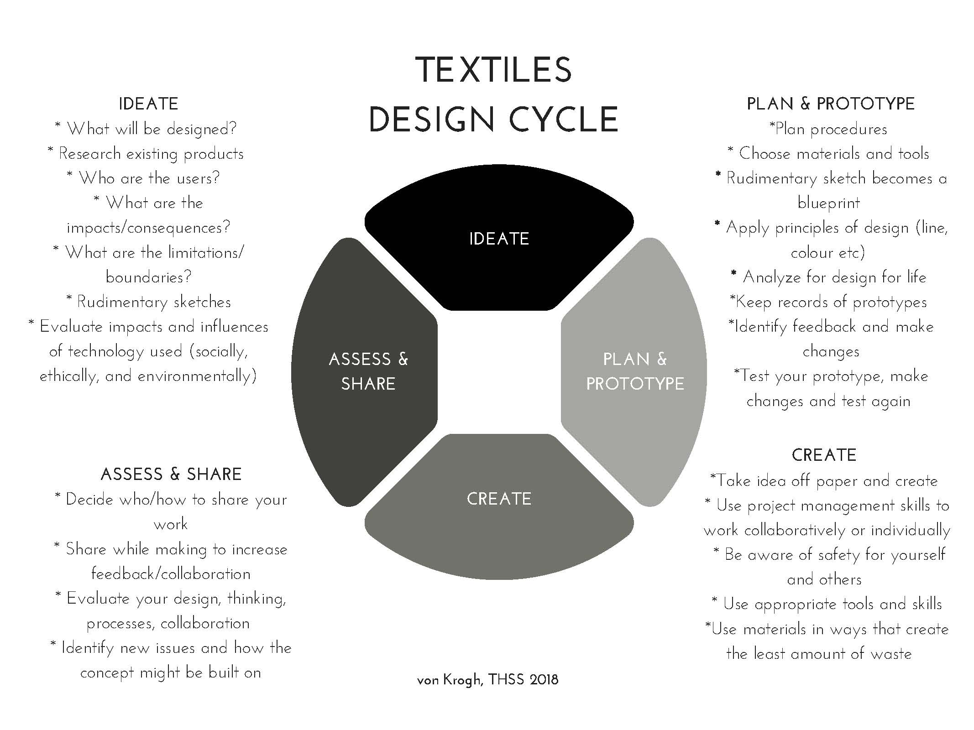

- Design Cycle reflections

IDEATE

PLAN/PROTYPE

CREATE

ASSESS/SHARE

- What are some new skills that you learned? Have you mastered that skill? Can you use it on another project?

- What are some of your areas to improve? How specifically will you improve?

- How did you use your time in Set Blocks? Did you attend and use Work Blocks?

I/F | C/C+ | B | A
- Not attending  - Little use of design cycle  - Project incomplete | - Using design cycle sometimes  - Focusing on one or two skills  - Completes task, with teacher prompting  - Requires assistance to following instructions/patterns  - Knows and apply all of the safety rules to work safely  - Sometimes choosing and using the appropriate tools for the tasks  - Attends some work blocks | - Reflective and using the design cycle regularly  - Learning new skills  - Good grasp of skills, shown in finished project  - Is able to follow a pattern / instructions with little assistance  - Knows and apply all of the safety rules to work safely  - Choosing and using the appropriate tools for the tasks  - Attending work blocks regularly | - Deeply reflective while using the design cycle  - Taking risks with learning = Learning and combining new skills  - Mastery of skills, shown in finished project  - Knows and apply all of the safety rules to work safely  - Demonstrating mastery of the technology/tools use for the technique  - Attending work blocks regularly

